Lake St. Louis Community Association

COURTS COMMITTEE MEETING

May 8, 2023 / 5:00 PM

Next Meeting: June 12, 2023, 5pm

Committee Members in Attendance:
- Bill Beach
- Sally Henderson
- Rick Knight
- Alex Kott
- Steve Lloyd
- Diane Seerey
- Ann-Marie Stagoski

Non-Committee Members in Attendance:
- Jim Dodds – Board Liaison

Meeting called to order at 5:03 p.m.

Minutes from April 10, 2023, LSLCA Courts Committee meeting had been distributed to all committee members via email. Modification was made to correct Peggy Leon’s last name as a Non-Committee Member in attendance. There were no other suggested changes to those minutes as written. Ann-Marie Stagoski made a motion to approve the Apr 10 minutes. Bill Beach seconded. Committee voted unanimously to approve.

No old business to review.

NEW BUSINESS:
- Safety and Maintenance: This topic will be added to the agenda on an ongoing basis to ensure the courts are safe for all our residents. Tennis gallery steps were identified as a trip hazard. Steve Lloyd and Rick Knight are going to investigate and bring a recommendation to the next Committee Meeting that can be presented to the Board.
- Lakewood Parking: Jim Dodds shared that the Board reviewed the recommendation for parking at the Lakewood courts and forwarded to Lakes and Parks for review.
- Committee Meeting Format: With the goal to keep Committee meetings contained to 60 minutes, Alex proposed meeting guidelines. After discussion, the attached meeting format (see attachment 1) was agreed upon by the Committee.
- Recent and Upcoming Event Review: Sally Henderson shared that approximately 24 individuals attended the tennis season kick off event. It was previously suggested to collect donations to support future tennis activities/events. As a result, $42.00 in tennis funds was collected. It was a great turnout and enjoyable day to play tennis. Next tennis event is the Memorial Day tournament, Saturday, 5/27/23 with rain date of Sunday, 5/28/23. Cost is $12.00 per person and includes lunch and a 50/50 raffle. Limit is 16 mixed doubles partners. An email blast from Becky is planned to generate attendance for event.
- Pickleball Open Play/Club Leads: We are still in need of one volunteer to support the Sunday morning youth open play. As attendance increases, a Lead is critical to ensure paddle racks are in place to regulate play ensuring everyone gets an opportunity to get on the court. Alex offered to show up on Sundays when available. Also, open plays attendance is not at expected levels. There was discussion on how to improve it …email, group texts, etc. Discussion tabled to give committee members time to generate a recommendation.
- Pickleball Signage Update: Bill stated that all signage is in place at both the CA and Lakewood are in place. Covered bench is also in place at Lakewood.
- Pickleball Clinic Updates: Clinics are 100% complete. 121 individuals have been trained which was about 77% of those that registered. Twenty, 1-hour sessions were completed. Jan Anderson was instrumental in helping design the content for the clinics. Thank you notes have been sent to Jan Anderson, Pat Alexander, Brenda Alexander, Vinh Truong, Steve Lloyd and Jack Smith for leading the clinics. Participant feedback was all positive. Interest in paid clinics was a 3.9 out of 5.0 and something to be evaluated as a future offer.
- Court Reservation Guidelines: Minor modification to be made to include the verbiage “as needed”. If there are not enough pickleball/tennis club players present to fill all the courts that were reserved, those courts will be made available to CA members if requested.
- CA Court Water Coolers: Rick Knight made the motion for the CA to provide ice water on the courts. Sally Henderson provided the second. Motion passed unanimously (see attachment #3).
- CA Court Player Covered Benches: Rick Knight made motion to purchase and install 3 - 8’ cabana benches. Ann-Marie Stagoski seconded. Motion passed unanimously (see attachment #4).
- CA Court Lighting: This issue will be tabled for a future Committee meeting as additional information is needed regarding lumens and LED versus halogen.
- Additional Discussion Items:
  - Courts Committee Website: Question was raised regarding a Courts Committee website along with a cloud site to store Courts Committee content/documents. There is currently no website. Content storage was being addressed by Stephanie Stone and topic was tabled until an update can be provided.
  - Courts Facebook Page: Discussion regarding whether CA members can post on the Courts Facebook Page which will be allowed but comments will be reviewed by administrator before being made public.
  - Coolers On Tennis Courts: Concern was raised regarding coolers with wheels being brought onto the courts and causing damage.
  - Raising and Lowering of Nets: Discussion tabled and to be revisited at the next Courts Committee meeting.
  - Portable Pickleball Nets: Additional investigation needed. Discussion tabled and to be revisited at the next Courts Committee meeting.

Bill Knight motioned to adjourn, and Ann-Marie Stagoski provided the second.
Meeting adjourned 6:07 pm

Respectfully Submitted,
Diane Seerey

Attachment #1

Committee Meeting Format
- Meeting duration target is 1 hour.
- Court safety & maintenance items at the top of the agenda item list to make sure they are discussed, and any necessary actions are agreed to for resolution.
- Chairman emails proposed agenda to committee members prior to meeting.
- Agenda finalized based on committee member input prior to Thursday before the meeting. No input denotes acceptance as written.
- Meetings follow finalized agenda.
- Additional topics not on final agenda will be addressed if time permits after all agenda items are discussed.
- Limit discussion on agenda items to 2 minutes if it is an FYI item or a depending on whether it is an FYI item or an action item report out. Proposed motions for the CA board to be time limited to 5 minutes but can be extended if majority of Committee members agree. If discussion cannot be completed in allotted timeframe, topic can be tabled for additional discussion after all remaining agenda items have been addressed or at a future Committee Meeting.
- Committee meetings will have a timekeeper to ensure meetings stay on track and final agenda items are discussed as agreed to.
- Not every action has to be a motion. Proposals to the CA board are what require motions, discussion and committee member votes. Examples of proposals requiring a motion are monetary expense related items for courts/clubs, court reservation requests, management of courts by CA employees, court usage fees for courts, club roster reviews, any studies related to court construction / utilization, contacting outside agencies, rules and regulations related to courts, etc.
- Committee members will prepare motions, actions and ideas before the meeting. Share them with other committee members via email to further develop them.
- Each motion should be clearly stated in writing, have a compelling need statement, concept mock-up, sketch or photo describing what is needed, a cost estimate, and supplier sourcing options to minimize discussion at committee meetings.
- No side conversations during meetings. Avoids distractions, makes sure everyone on committee participates in discussion, reduces wasted time rehashing conversations on a certain topic.
- CA Members (not Committee members) attending a meeting will be asked to hold questions and input until after Committee members have concluded discussion, if called upon by the Chairman.

Attachment #2

Action items
- Investigate tennis gallery step trip hazard - Steve / Rick
- Email blast for Memorial day tournament - Sally
- Attend youth open plays on Sundays - Alex
- Investigate offering future paid for pickleball clinics - TBD
- Present motions for CA Court Ice Water & CA Benches at next board meeting - Alex
- Determine best way to increase open play attendance - Ann-Marie / Alex

Attachment #3

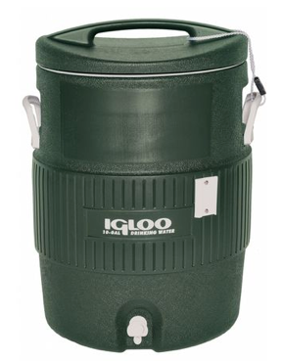
Ice water for CA COurts

Recommendation
Provide on-court ice water for CA members that play tennis and pickleball at the CA clubhouse courts.

Benefits
- Provides quick and easy access to water while playing tennis or pickleball without delaying play.
- Ensures safety of all players by providing a readily accessible water supply on courts.
- Provide ice cooled water similar to water provided on golf course.
- Helps CA members see the value of paying for an amenity pass.
- Gives the look and feel of an upscale country club or resort which helps CA member experience.
- Help retain amenity paying tennis and new pickleball club (231) players in LSLCA.

Specific Actions
Place ice water containers inside courts for all members to quickly access between games. Put ice water containers just inside the court entrance gate to save time and energy hauling water to the middle of courts. Only fill containers three quarters to half way if it appears water isn’t being fully consumed.

Other Info / Considerations
- SAFETY - In our group there are three members over 80 years old who play regularly and multiple players are over 70 years old. When a player forgets to bring a water bottle (which has happened) a serious concern of dehydration is possible when temperatures are high.
- I have spoken with the golf course personnel and have been told it would be no problem. They go right past the courts every day after delivering water to the golf course.
- Water containers (previously used on the courts) are still available. So new coolers would not need purchased.
- Stopping play in the middle of a match to get a drink or refill a bottle takes too long and interrupts play.

Resources needed
SUPPLIES/MATERIAL … Minimal, ongoing cost of paper cups (same ones currently used for golf course).
LABOR… Minimal (5 minutes for fill and placement inside the gate) for golf course personnel.
CAPITAL… None needed for coolers, since coolers previously used are still available.

Attachment #4

CA CoURT CABANA Benches Proposal
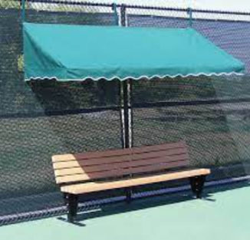
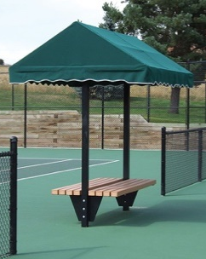
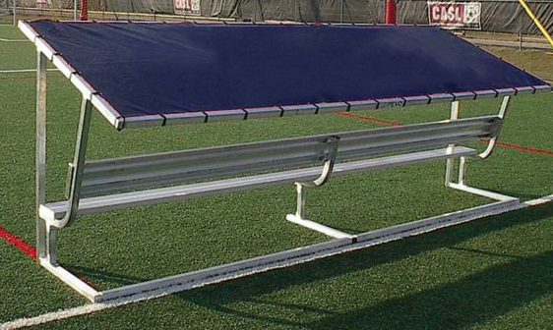
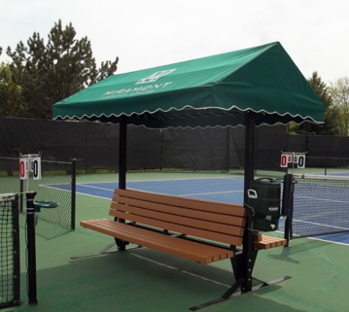

Sun Trends / Active Sports Pevo Sports Co. Har-Tru Har-Tru
(2 sided w/ backrest) (1 sided w/ backrest) (2 sided) (fence side bench & cabana)

Recommendation
Provide seating and shade for LSLCA members during tennis and pickleball playing times.

Benefits
- Provides seating area during play to cool down between tennis and pickleball games.
- Provides relief from sun to reduce sun burn and provide cooler area during play.
- Provides an on-court waiting area for tennis and pickleball players when player rotations are being observed (ie odd number of players present, pickleball open play clubs).
- Minimizes distractions and disruption from players standing or walking around during game play.
- Helps CA members see the value of paying for an amenity pass.
- Gives the look and feel of an upscale country club or resort which helps CA member experience.
- Help retain amenity paying tennis and new pickleball club (231) players in LSLCA.

Specific Actions
Finalize pricing for cabana benches (see supplier examples at the top). Select and purchase 3 sets of 8’ long covered benches (preferred with back support) for courts at the CA clubhouse. If funding requirements exceed budgetary limits/priorities, consider purchasing smaller quantities and add more in time as funding becomes available. Install benches between each court (1-2, 2-3, 3-4). Repurpose current benches to area under the current CA deck near the pool area. Use cut down referee chairs to support ice water containers inside the courts (see additional proposal for ice water).

Resources needed
CAPITAL … Total cost for 3 benches would be $4,200 – $11,970.
- Sun Trends, 2 sided w/ backrest 8’ long … $3,990 each
- Pevo Sports, 1 sided with backrest 7.5’ long … $1,351 each
- Har-Tru, 2 sided 8’ long …. $2,990 each
- Har-Tru, fence side bench & cabana 6.5’ long … $970 each
LABOR … Bench assembly and installation. Moving / repurposing existing benches.
SUPPLIES/MATERIAL … Not aware of anything.

