Lake St. Louis Community Association
COURTS COMMITTEE MEETING
February 13, 2023 / 5:00 PM
Next Meeting: March 13, 2023, 5pm

Committee Members in Attendance:
- Steve Lloyd
- Rick Knight (via Zoom)
- Alex Kott
- Ann-Marie Stagoski
- Diane Seerey

Non-Committee Members in Attendance:
- Jim Dodds – Board Liaison
- Sally Henderson
- Peggy Leon - resigned member

Called to order at 5:03 p.m.

Ann-Marie Stagoski and Alex Kott reviewed the January 9, 2023 minutes. Ann-Marie Stagoski made motion to approve the meeting minutes, seconded by Steve Lloyd. Committee voted unanimously to approve the Jan 9, 2023 meeting minutes.

OLD BUSINESS:

- Committee Presentation to CA Board:
  - Alex Kott reviewed the outcome of the Courts Committee presentation regarding the Courts Committee Charter at the CA Board meeting. The Board rejected the suggestion to change the words in the Courts Committee Charter to “tennis and pickleball courts” where it currently reads “sport courts”. The Board did approve to modify the verbiage “sport courts” to read “courts” which will provide for future flexibility for the Courts Committee to address other court related activities.
  - Alex Kott stated that the Board did approve the Courts Committee Officer elections which are Alex Kott - President; Stephanie Stone – Vice President, and Diane Seerey – Secretary. However, the Board rejected the Courts Committee Members terms that were presented because two members, Richard Knight and Peggy Leon, are from the same household. As a result, Peggy Leon agreed to resign from the Courts Committee. Approval of Committee Member terms will be readdressed by the Board once a replacement for Peggy Leon has been identified.
- Alex Kott shared resume of Sally Henderson as a potential replacement for Peggy Leon. Rick Knight made motion to approve Sally Henderson, seconded by Ann-Marie Stagoski. The Committee unanimously approved recommendation to make Sally Henderson a member of the Courts Committee. Alex Kott will present the updated committee members and terms to the CA Board on 2/28/23 for approval.
- Pickleball Interest Survey Results:
  - Alex Kott provided a summary of the Pickleball Interest Survey that was distributed to owners (see Attachment #1).
- Alex Kott reviewed a proposed pickleball schedule (see Attachment #2). Ann-Marie Stagoski made the motion to present proposed schedule to CA Board with one modification being Couple Social will begin effective 5/25/23. Motion was seconded by Steve Lloyd. Committee unanimously approved recommended schedule as amended. Subsequent to meeting it was found that there is an additional conflict in the Fall (Aug/Sep) with Couples social and Jr tennis clinics on Thursday evenings at the CA courts. In addition, there was a concern expressed that families usually play tennis during the weekend mornings due to work conflicts during the week. Therefore, it was recommended to move weekend pickleball activities to the Lakewood courts to allow families the opportunity to play tennis if they wish to do so. New proposed schedule addressing those issues is attached and has been approved by the majority of the committee members via email. As a result, new proposed schedule dated Feb 21 does not contain any day or time changes. The only modifications made from original approved schedule are to the location of the pickleball activities on Thursday evening, Saturday and Sunday mornings. Couples social on Thursday evenings will not be delayed to May 25. Instead, it will be able to start sooner on April 6. New proposed schedules are attached for pickleball and tennis leagues in Attachment #2. Alex Kott will present the proposed schedules to the CA Board on 2/28/23 for approval.

NEW BUSINESS:

- There was discussion regarding the concern about lack of parking and restrooms at the new Lakewood pickleball facility. Jim Dodds stated the Board is evaluating improvement options for both issues and suggested that the Courts Committee raise the issue at the upcoming Board meeting to emphasize the concern and request a resolution.
- The need for individuals with pickleball experience to support the proposed pickleball clinics (see Attachment #1) was raised. Steve Lloyd stated he and Bill Beach would be willing to support. Steve Lloyd also agreed to reach out to the 21 owners who expressed interest in volunteering (see Attachment #1) to solicit help to facilitate the proposed clinics.
- Ann-Marie Stagoski shared the work that has been done on the Lake Saint Louis Community Association Pickleball Club Facebook page. Facebook page will be used to help communicate activities and events to members. Diane Seerey made the motion to move forward and make the Facebook page official and go live with Steve Lloyd providing the second. The Committee unanimously approved.
- Alex Kott shared a list of pickleball startup supplies, on behalf of Bill Beach, (Outdoor bulletin board, court number signs, video surveillance signs and paddle racks) that will be needed to support the proposed pickleball activities. Jim Dodds stated that the list of supplies needs to be provided to Heather Becker for procurement. Ann-Marie Stagoski made a motion to provide the list for approval and procurement with Diane Seerey providing the second. The Committee unanimously approved recommendation to request pickleball activity startup supplies for courts to support leagues and clinics.
- Alex Kott shared that he had incurred a $100 expense to access and download the Pickleball Interest Survey responses. Jim Dodds stated that the invoice needs to be provided to Heather Becker for reimbursement. Diane Seerey made the motion to move the invoice forward for reimbursement and Steve Lloyd provided the second. The Committee unanimously approved recommendation to reimburse Alex for expense.
- There was discussion regarding Pickleball’s representation at the March 3rd Owners’ Open House. It was agreed that two tables would be needed, and Ann-Marie Stagoski will relay that need to Becky. There was additional discussion regarding the Courts Committee’s objective at the Open House which is to encourage owners to get involved and sign the Pickleball roster providing name, email address, telephone number and areas of interest. Alex Kott and Ann-Marie Stagoski will work to create roster form and what will be displayed at the Pickleball “booth”.
- It was noted that there were audio difficulties with Zoom call for remote participants. There was also screen sharing connectivity issues with Alex’s computer. Alex will work on loading the Zoom app on the laptop to resolve screen sharing issues. Diane is going to try and find a speaker phone to use for next meeting to improve audio for next meeting.

It was agreed that the next Courts Committee meeting will be held on March 13, 2023.

Meeting was adjourned at 6:35 PM.

Action Items:
* Request approval for updated committee members and terms to the CA Board on 2/28/23 (Alex Kott)
* Request approval for proposed schedules to the CA Board on 2/28/23 (Alex Kott)
* Request approval for pickleball league startup supplies to the CA Board on 2/28/23 (Alex Kott)
* Request reimbursement for survey response access & download at Feb 28 CA Board Mtg (Alex Kott)
* Email pickleball survey results to CA Board (Alex Kott)
* Share Lakewood facility parking & restroom concerns with the CA Board on 2/28/23 (Alex Kott)
* Reach out to the survey volunteers to ask for help on conducting clinics (Steve Lloyd)
* Share Lake Saint Louis Community Association Pickleball Facebook page. (Alex Kott)
* Determine handouts and materials needed for pickleball booth at March 3 open house (Ann-Marie)
* Request tables for March 3 open house (Ann-Marie)
* Improve Zoom meeting issues for next meeting (Alex & Diane)
* Update Court Committee Charter as recommended and post to Courts Committee webpage (J. Dodds)

Respectfully submitted,

Diane Serrey
Secretary, Courts Committee

Lake St. Louis Courts Committee
2/13/23 Meeting Minutes

Attachment #1

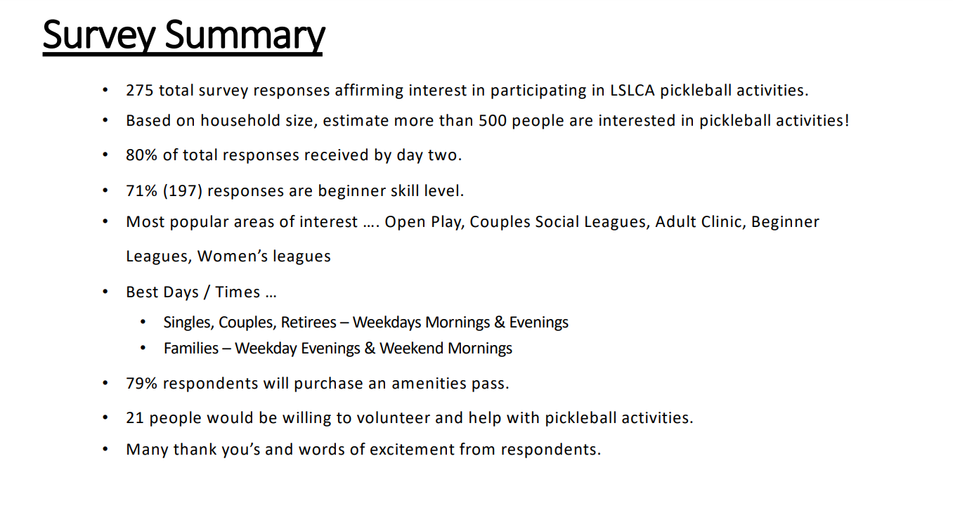

Lake St. Louis Courts Committee
2/13/23 Meeting Minutes

Attachment #2

