Lake St. Louis Community Association

COURTS COMMITTEE MEETING

April 11, 2023 / 5:00 PM

Next Meeting: May 8, 2023, 5pm

Committee Members in Attendance:
- Rick Knight
- Alex Kott
- Ann-Marie Stagoski
- Sally Henderson
- Stephanie Stone

Non-Committee Members in Attendance:
- Jim Dodds – Board Liaison
- Peggy Knight
- Rolf Albers
- Tom Curcio

Called to order at 5:04 p.m.

Minutes from March 13, 2023 LSL CA Courts Committee meeting had been distributed to all committee members via email. There were no suggested changes to those minutes as written. Stephanie Stone made the motion to approve the 2/13/23 minutes with 2nd provided by Ann-Marie Stagoski. Committee voted unanimously to approve.

OLD BUSINESS:
- Committee Presentation at March LSLCA Board Meeting:
- Reviewed approved tennis clubs
- Reviewed approved pickleball clubs
- Reviewed approved tennis events
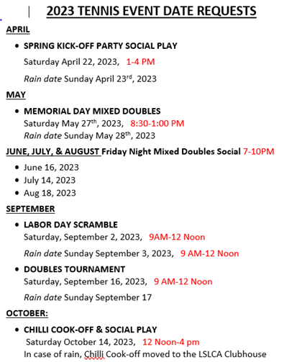
- Suggested dates that the committee would like on the LSLCA calendar be sent to Becky
- New tennis kickoff and Memorial Day flyers will be sent by Sally to the CA to be sent out to the CA email. Sally will also be updating the tennis bulletin board with new schedules and events flyers.

NEW BUSINESS:
- Open play club volunteers: Ann-Marie discussed pickleball open play club volunteers. Rick asked about a sign in sheet. Alex commented that there is already a sign-up sheet system in place. Sign in sheet was shared with the committee members.
- Fees collection: Rick moved to suspend collecting fees from non-CA people who come to play tennis due to a perceived fees collection inequity with non-CA pickleball players at Lakewood courts. There was no second. Jim Dodds said that that board is aware of the challenge of collecting money for non-CA or non-amenity pass members who would like to play pickleball at the Lakewood Courts. Stephanie Stone moved to turn in sign up sheets for tennis and pickleball to the CA and leave it up to the CA to take action on collecting fees. There was no second. Sally said that it may be more useful at the Lakewood Courts. Jim Dodds said that Heather is the person who would come up with the solution. Stephanie Stone moved to collect sign in sheets and she will keep track of them and who is a CA member. There was no second.
- Club bylaws: Alex suggested that we update the club bylaws to add lead responsibilities so they offer more guidance and clarity for the club lead role. He shared the following bullets as ideas that could be added to improve clarity. Stephanie Stone suggested reviewing and discussing this option and come back next month. Stephanie Stone will put something in Google sheets for committee members to review, edit and improve.
  - Coordinate daily club play times, maintain / update roster, propose schedule to courts committee 4Q, submit roster to Courts 1Q.
  - Follow the rules set out by the LSLCA Board
  - Cooperate with LSLCA Courts Committee and the other courts related clubs
  - Openly discuss and work with others to resolve any conflicts that come up
  - Avoid monopolizing court time
  - Propose court time reservation requests that are proportional to actual usage
  - Follow and enforce guidelines (Etiquette, net heights, music, etc...) for courts usage
- Events coordinator: Discussed whether an Events Coordinator on the Courts Committee to lead and organize all courts committee events. Discussion on whether tennis and/or pickleball would like separate coordinators. It was suggested that each individual group meet to come up with ideas.
- LSLCA Communications: It was proposed to request the use of the LSLCA email for communications for events to reach a broader group. All agreed.
- CA Courts Trash: Tom asked that the court committee communicate the request to the CA to empty waste baskets at the CA courts. They were overfull at time of committee meeting. Alex volunteered to send email to CA to request trash emptied.

After 6:33 there was no longer a quorum since Rick Knight left meeting. However, the following items were discussed with 4 committee members still present:

- Pickleball signage – one paddle rack and bulletin board at Lakewood Courts installed.
- Concrete pad at Lakewood Court installed
- Bench with awning at Lakewood Courts are a couple of weeks away
- Discussion of putting rock down for parking at Lakewood Courts
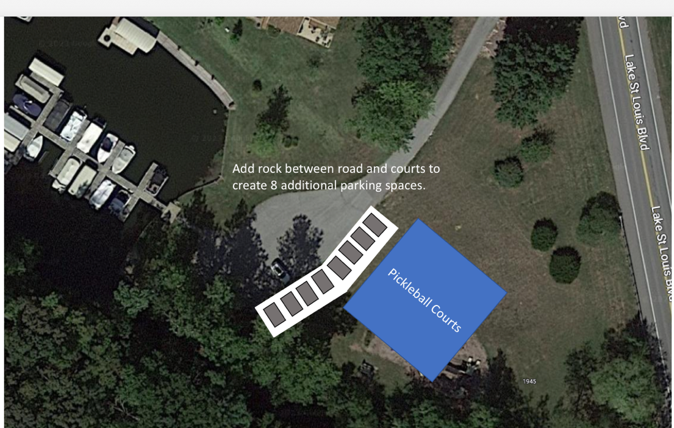
- Jim Dodds said electricity and bathroom are there now.
- City will extend the guardrail near the Lakewood Courts.
- Pickleball Clinics are halfway done and attendance and feedback are positive.
  - 10 sessions completed (4/3am, 4/3pm, 4/4pm, 4/5pm, 4/10am)
  - 10 sessions left (4/12pm, 4/14am, 4/14pm, 4/15am youth, 4/16am youth)
  - 61 attendees so far / 25 no shows / 71% participation rate
  - Instructors: Jan Anderson, Vinh Truong, Jack Smith, Pat Alexander, Alex Kott
  - Survey feedback so far positive…
    - 5 stars on instructor helpfulness, clinic content, recommend to a friend.
    - Nearly 5 stars on courts conduciveness to learning about pickleball.
    - 59% favorable responses taking additional in-depth clinics from a certified professional at a cost.
    - Comments …
      - Plusses: Great Intro, thank you, fun, excellent overview / education, loved it, helpful, more clinics please, great instructors, informative
      - Improvements: too windy, need more courts, make each tennis court 2 pickleball courts / portable pickleball nets, parking needs improved / more parking, paddle recommendations

- Ask leads if they move anything (benches) to please put them back in their original place. It was noticed that a bench on court 4 of CA courts was not on the side of the court. It was moved to the behind the baseline against the fence. Could be a safety hazard if someone playing on the court ran into it.
- Jim Dodds shared a conversation with Rick that court 3 repairs left a hump in the court and that it needs addressed. In Rick’s opinion it is a safety issue. Alex agreed to forward concerns to the CA representative and ask for resolution.
- Committee meeting time length concerns discussed. Following ideas were shared …
  - Committee could meet and vote virtually like the board does.
  - Prepare motions, actions and ideas before the meeting. Share them with committee members via email to further develop them to minimize discussion at committee meetings.
  - Limit meeting discussion to agenda items only.
  - Any topic not on agenda proposed for discussion can be discussed at the end of the agenda.
  - Limit discussion on agenda items to 2 minutes.
  - Reduce number of agenda items for committee meetings.
  - Not every action has to be a motion. Proposals to the board are what needs motions and votes.
  - Stop side conversations during meetings to avoid distractions rehashing conversations on a certain topic.

Meeting adjourned 7:03pm

Respectfully Submitted,

Ann-Marie Stagoski

